Runtime Report

Machine 1

|  |
| --- |
| CPU: Intel i7-11370H |
| GPU: Nvidia RTX 3050Ti |
| RAM: 40GB |
| Storage: 1.5TB SSD |



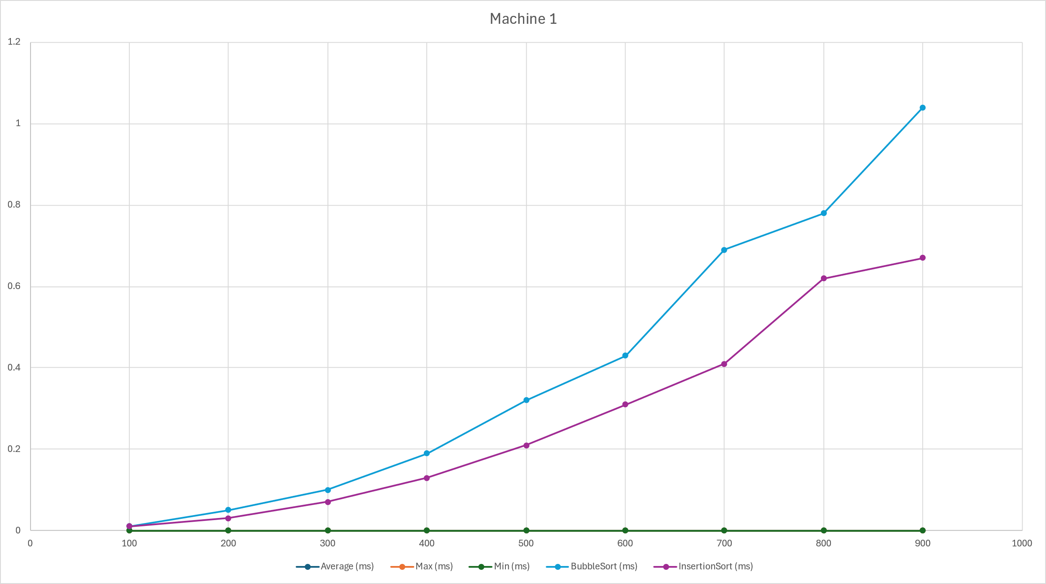





Machine 2

|  |
| --- |
| CPU: Ryzen 5 5600 |
| GPU: RX 6700XT |
| RAM: 16GB |
| Storage: 1TB SSD |
|  |



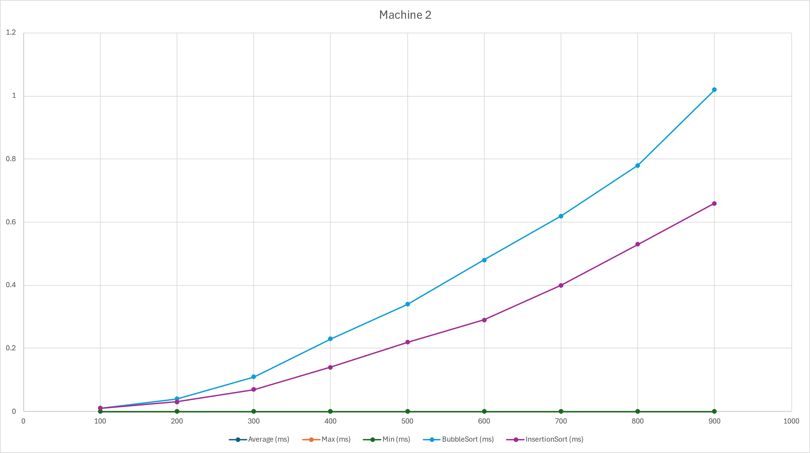



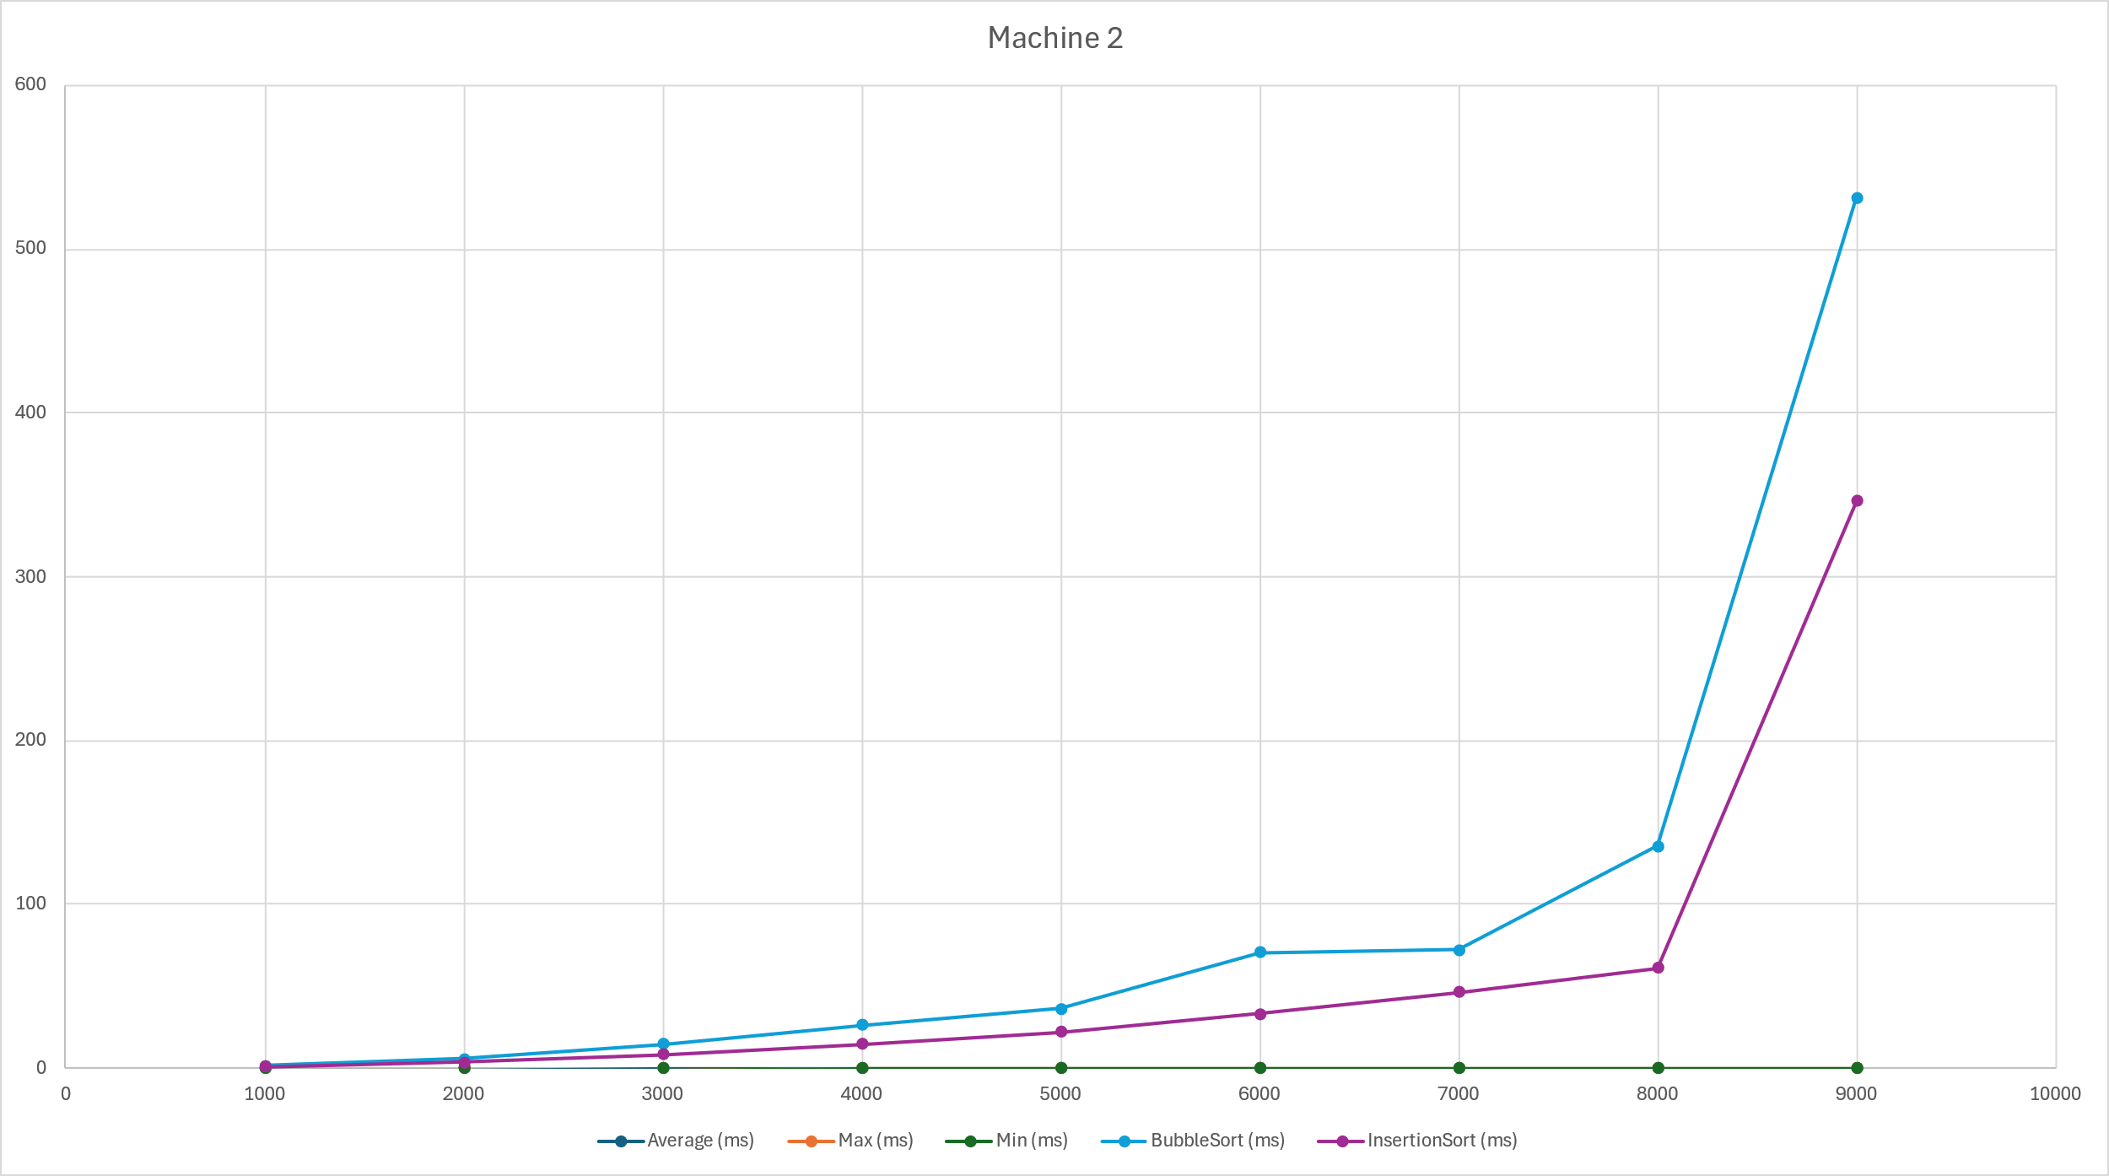

Machine 3

|  |
| --- |
| CPU: Ryzen 5 5500 |
| GPU: Nvidia RTX 4060 |
| RAM: 16GB |
| Storage: 500GB SSD |
|  |



